Osman: I chose the Charity table because it has clear fields for practicing SELECT, INSERT, UPDATE, and DELETE. It also connects to the Donation table through Charity, so I can show how that relationship affects deleting a charity.

Create
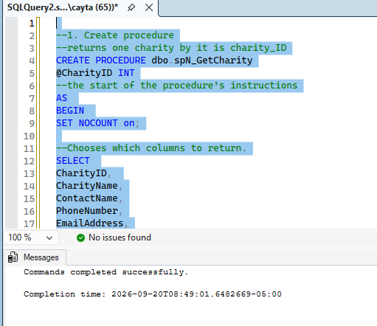
TEST
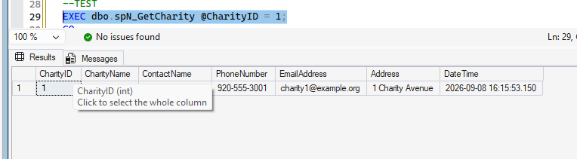
INSERT
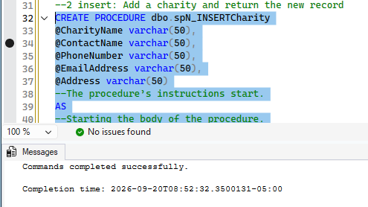
Test
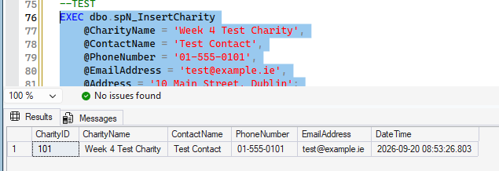
UPDATE
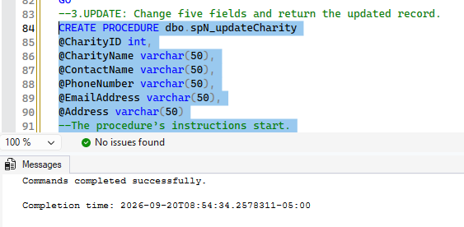
TEST
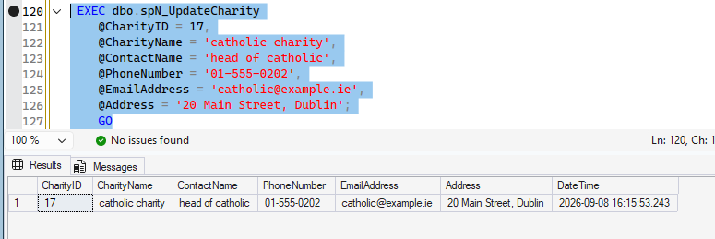
DELETE
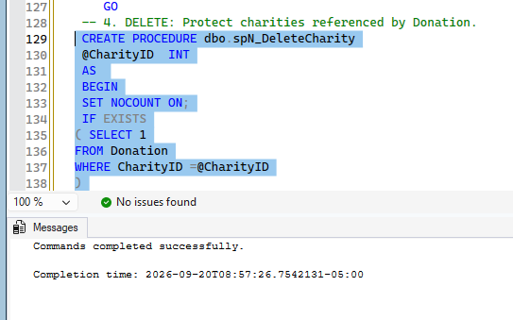
Test
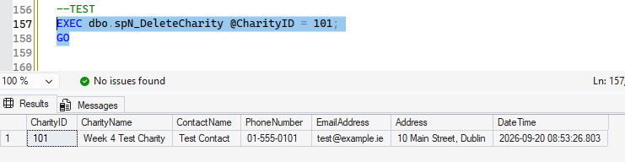
VERIFY
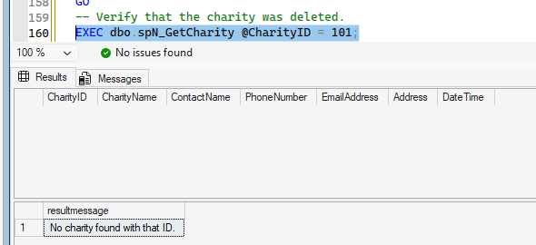
For the Charity table, the stored procedures are named spN_GetCharity, spN_InsertCharity, spN_UpdateCharity, and spN_DeleteCharity.

